# Analytics Workshop with R & Tableau

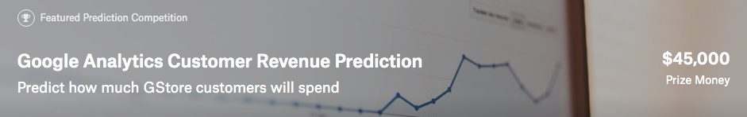

### Description: <https://www.kaggle.com/c/ga-customer-revenue-prediction>

The 80/20 rule has proven true for many businesses–only a small percentage of customers produce most of the revenue. As such, marketing teams are challenged to make appropriate investments in promotional strategies.

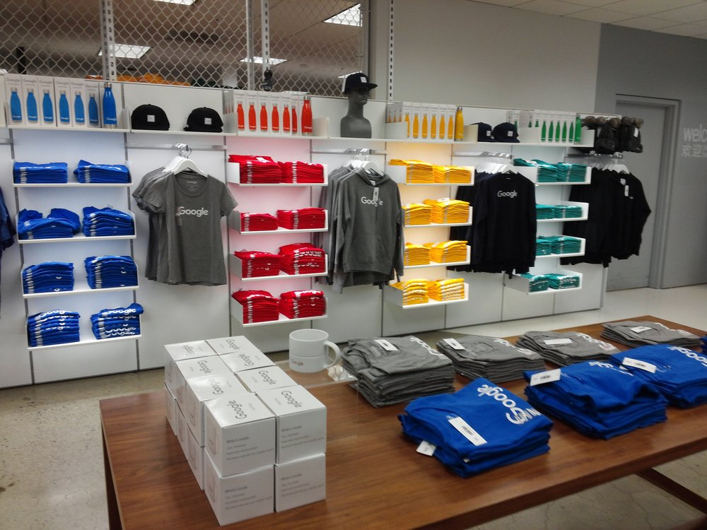RStudio, the developer of free and open tools for R and enterprise-ready products for teams to scale and share work, has partnered with Google Cloud and Kaggle to demonstrate the business impact that thorough data analysis can have.

In this competition, you’re challenged to analyze a Google Merchandise Store (also known as GStore, where Google swag is sold) customer dataset to predict revenue per customer. Hopefully, the outcome will be more actionable operational changes and a better use of marketing budgets for those companies who choose to use data analysis on top of GA data.

### What to predict ?

We are predicting the **natural log** of the sum of all transactions **per user**. For every user in the test set, the target is:

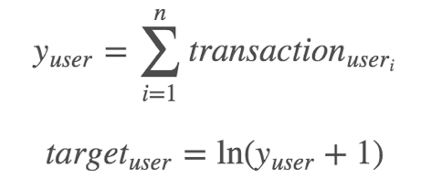

### Evaluation: Root Mean Squared Error (RMSE)

Submissions are scored on the root mean squared error. RMSE is defined as:

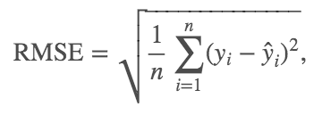

where y hat is the natural log of the predicted revenue for a customer and y is the natural log of the actual summed revenue value plus one.

### Data Fields

* ***fullVisitorId***- A unique identifier for each user of the Google Merchandise Store.
* ***channelGrouping*** - The channel via which the user came to the Store.
* ***date*** - The date on which the user visited the Store.
* ***device*** - The specifications for the device used to access the Store.
* ***geoNetwork*** - This section contains information about the geography of the user.
* ***socialEngagementType*** - Engagement type, either "Socially Engaged" or "Not Socially Engaged".
* ***totals*** - This section contains aggregate values across the session.
* ***trafficSource*** - This section contains information about the Traffic Source from which the session originated.
* ***visitId*** - An identifier for this session. This is part of the value usually stored as the _utmb cookie. This is only unique to the user. For a completely unique ID, you should use a combination of fullVisitorId and visitId.
* ***visitNumber*** - The session number for this user. If this is the first session, then this is set to 1.
* ***visitStartTime*** - The timestamp (expressed as POSIX time).
* ***hits*** - This row and nested fields are populated for any and all types of hits. Provides a record of all page visits.
* ***customDimensions*** - This section contains any user-level or session-level custom dimensions that are set for a session. This is a repeated field and has an entry for each dimension that is set.
* ***totals*** - This set of columns mostly includes high-level aggregate data.

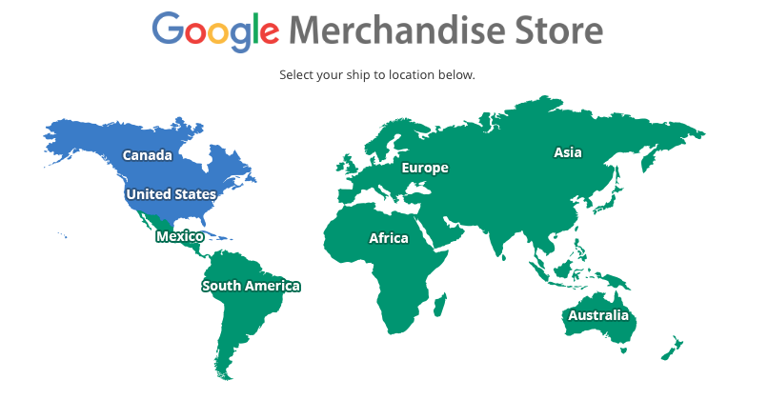

<https://www.googlemerchandisestore.com/>

Google Merchandise Store – Google Analytics

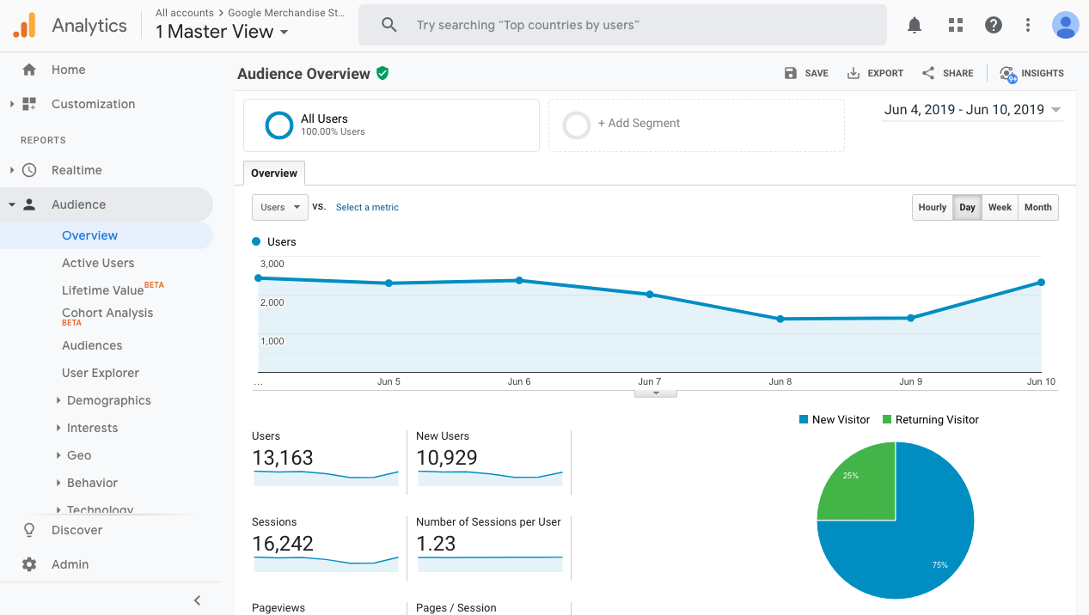

<https://analytics.google.com/analytics/web/demoAccount>

## Workshop Guide

## Workshop Exercise

Question 1 : How many months of data are there in training data?

Your answer :

Question 2 : How many months of data are there in testing data?

Your answer :

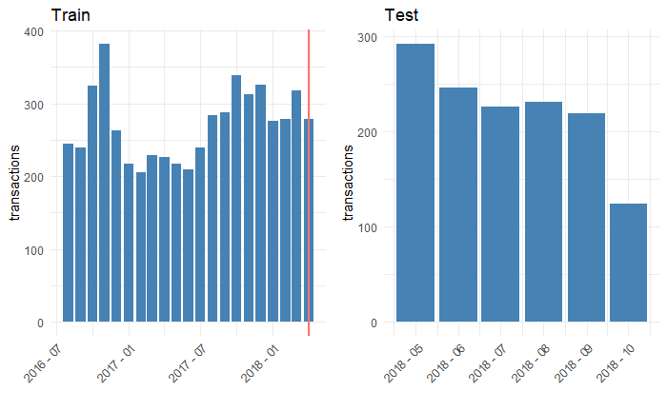

Question 3 : What’s the **variable name** of the target we want to predict: customer revenue?

Your answer :

﻿ [1] ﻿"channelGrouping" "date"

[3] "fullVisitorId" "visitId"

[5] "visitNumber" "visitStartTime"

[7] "browser" "operatingSystem"

[9] "isMobile" "deviceCategory"

[11] "continent" "subContinent"

[13] "country" "region"

[15] "metro" "city"

[17] "networkDomain" "campaign"

[19] "source" "medium"

[21] "keyword" "isTrueDirect"

[23] "adContent" "referralPath"

[25] "adwordsClickInfo.page" "adwordsClickInfo.slot"

[27] "adwordsClickInfo.gclId" "adwordsClickInfo.adNetworkType"

[29] "adwordsClickInfo.isVideoAd" "hits1"

[31] "pageviews" "timeOnSite"

[33] "sessionQualityDim" "newVisits"

[35] "bounces" "transactionRevenue"

## Workshop Feedback